
Symbiosis Institute of Technology, Pune
Faculty of Engineering
CSE- Academic Year 2026-27
Java Programming – Lab Batch 2024-28
Lab Assignment No: - 26
Name of Student: Sanika Botre
PRN No.: 25070122063
Batch: 2025-29
Class: CSE A-2
Academic Year & Semester: 2026 & 3rd Semester
Date of Submission
Title of Assignment: Write a Java program to create and execute multiple threads using the Runnable interface.
Learning Objectives: To create multiple threads using the Runnable interface.

Theory:
The Runnable interface provides an alternative approach to creating threads in Java. A class implementing Runnable defines the run() method that contains the code executed by the thread. The Runnable object is passed to a Thread object, which starts execution using the start() method. Unlike extending the Thread class, implementing Runnable allows a class to inherit from another superclass, making the design more flexible. Runnable separates task definition from thread execution, resulting in better code organization and reusability. It is widely used in multithreaded enterprise applications and thread pool implementations.
Practice questions
1. Create a program using Runnable to run two tasks simultaneously.
Code:
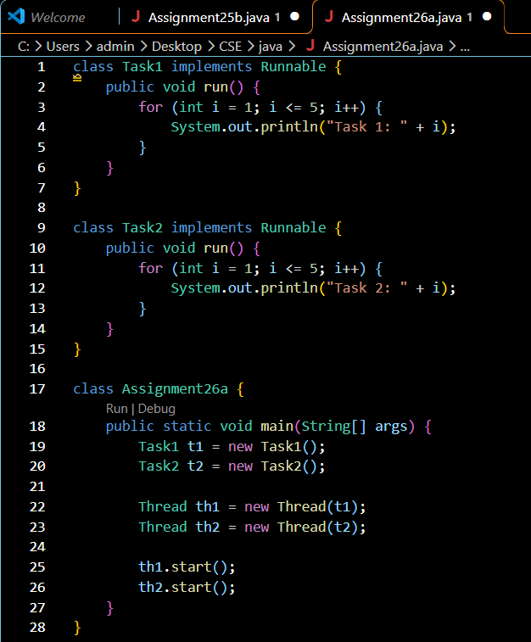
Output:
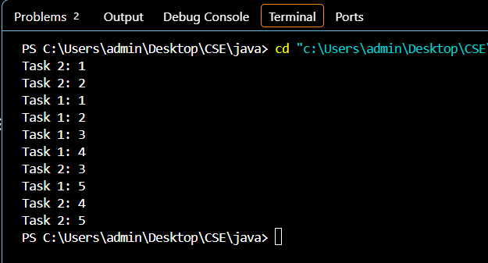
2. Create a Java program using the Runnable interface where two tasks run simultaneously: one thread performs deposit operations, and another performs withdrawal operations, both displaying results concurrently.
Code:
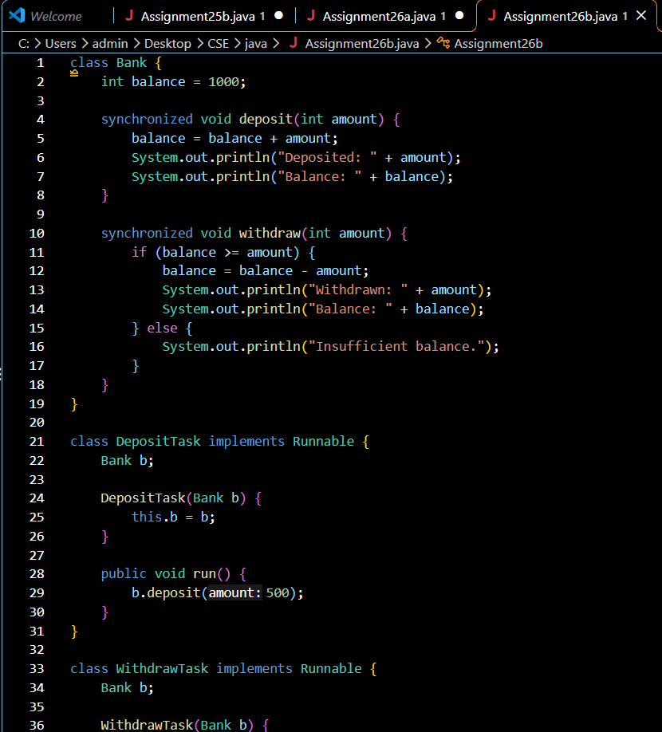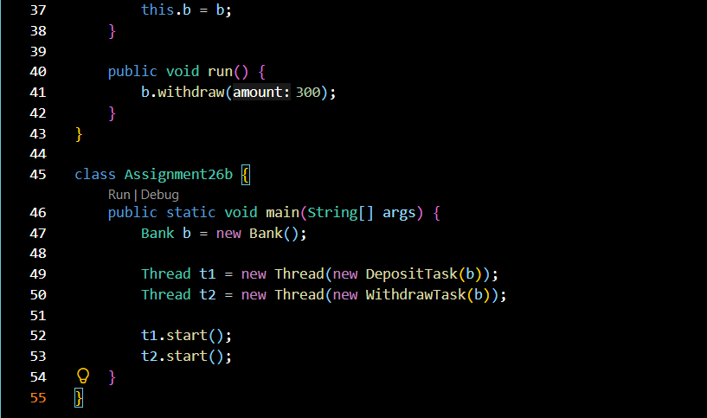
Output:
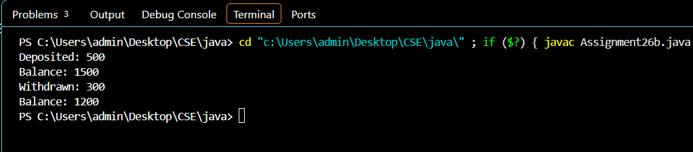

Conclusion
Thus, both programs were successfully implemented using the Runnable interface in Java. The first program executes two tasks concurrently, while the second simulates bank deposit and withdrawal operations using separate threads. Synchronization ensures safe access to the shared bank balance and helps maintain correct transaction results.

